

LIST OF PROJECT COMPLETED
A . PROJECT TITLE

- ) CONSTRUCTION OF CONCRETE PAVEMENT LOCATED AT TISA , ELEMENTARY SCHOOL IN BRGY. TISA , LABANGON CEBU CITY

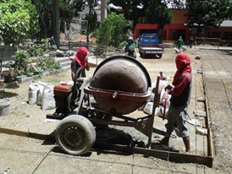
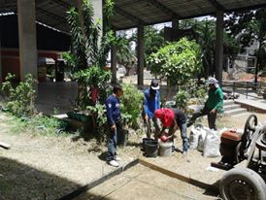

PROJECT AMOUNT : PHP 350,000.00

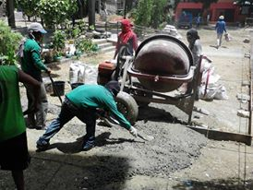

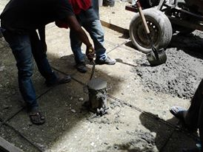

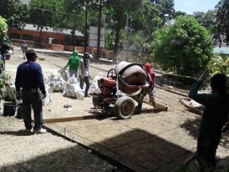

- ) CONSTRUCTION OF LINED CANAL WITH COVER LOCATED AT SITIO KAPAKULAN , BRGY. TISA , LABANGON CEBU CITY

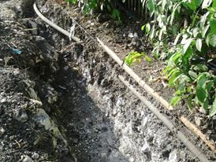
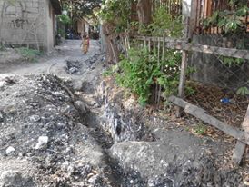

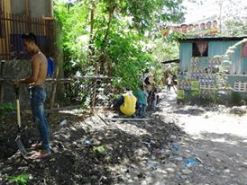
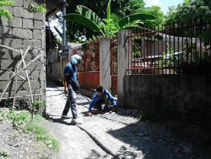
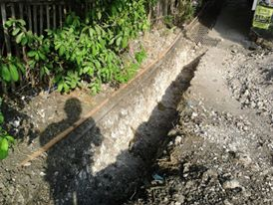
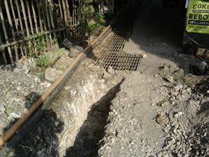
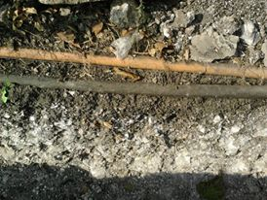
PROJECT AMOUNT :
PHP 620,000.00

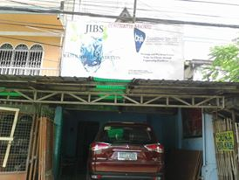
COMPANY OFFICE IS AT 1-27 ZONE OKRA, PAKNAAN, MANDAUE CITY WITH AN AREA OF 200 SQ. MTRS, 2 STOREY BUILDING

COMPANY SERVICE VEHICLE :

1.) MITSUBISHI, MONTERO SPORTS, SUV

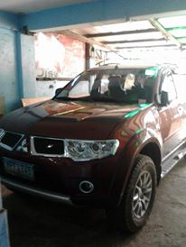

2.) HYUNDAI ION-110

3.) MITSUBISHI CANTER, 6W

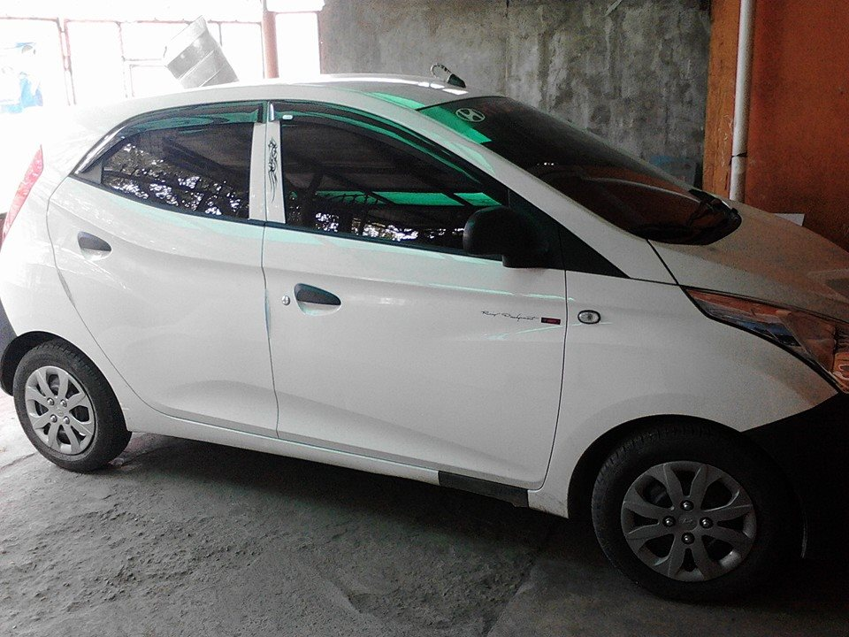

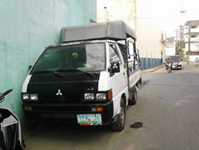

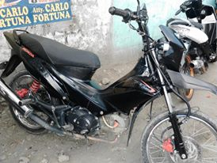

4.) 125 XRM- HONDA, MOTORCYCLE

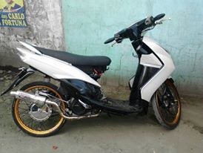
5.) 110 MIO, SCOOTER

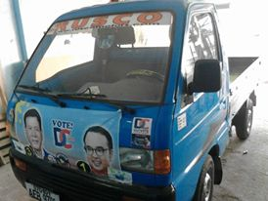

6.) PICK UP TYPE, MULTICAB 12V

